EXP- 2
Bus Ticket Booking Prototype (Figma) Aim To design a simple Bus Ticket Booking System prototype using Figma.

Procedure
1. Open Figma and create a new design file.
2. Design screens: • Home Page • Search Bus • Seat Selection • Payment Page
3. Add navigation links.
4. Present prototype mode.

Output :
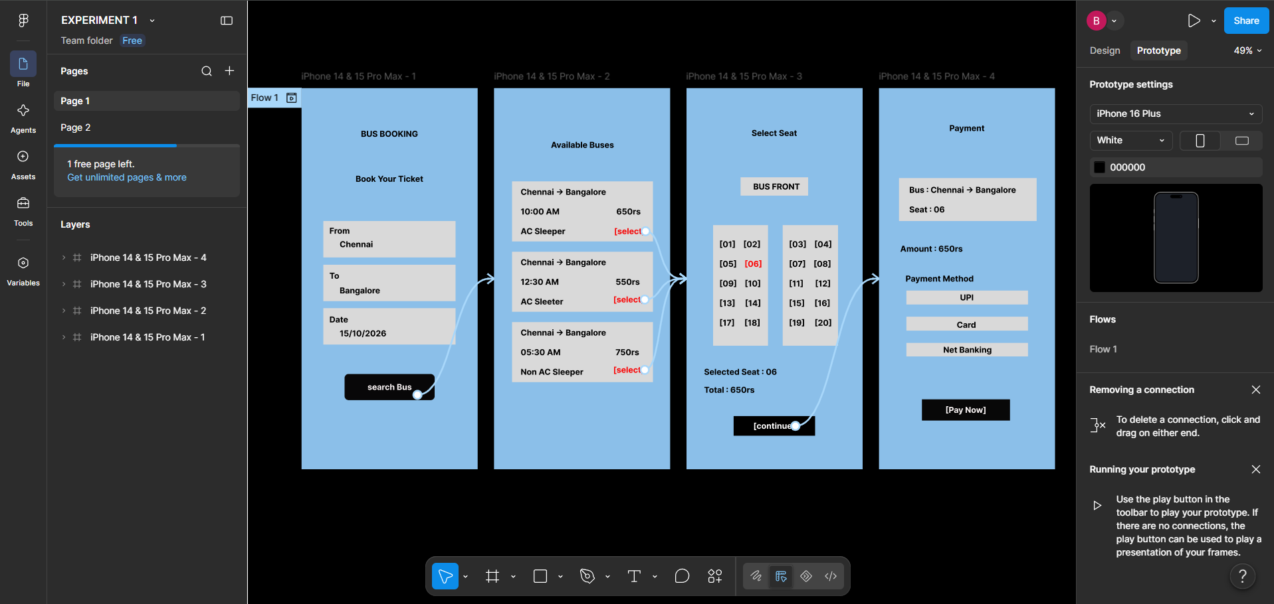

Result:
Thus, The clickable prototype of Bus Ticket Booking System was created successfully

